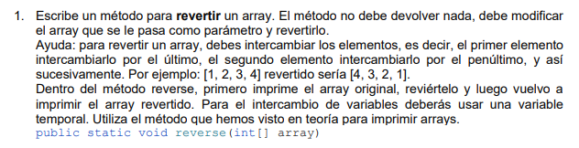

import java.util.Arrays;
public class TestArrays {
public static void reverse(int[] array) {
System.out.println("Array original: "+ Arrays.toString(array));
for (int i = 0; i < array.length / 2; i++){
int aux = array[i];
array[i] = array[array.length -1 -i];
array[array.length -1 -i] = aux;
}
System.out.println("Array revertido: "+ Arrays.toString(array));
}
}
public static void main(String[] args) {
int[] fuente = {9, 18, 25, 7, 24};
TestArrays.reverse(fuente);
}

